Integrating the Healthcare Enterprise



IHE PCC

Technical Framework Supplement

Patient Plan of Care
(PPOC)

Public Comment

Date: May 5, 2009
Author: Keith W. Boone
Email: keith.boone@ge.com

This is a supplement to the IHE PCC Technical Framework V4.0

It is submitted for Public Comment between June 1, 2009 and July 1, 2009.
Comments shall be submitted within that period to http://forums.rsna.org:
- Select the “IHE” forum
- Select PCC Technical Framework
- Select 2009-20010 Supplements for Public Comment
- Select Patient Plan of Care
Please use the Public Comment Template provided there when starting your New Thread.

Details about IHE may be found at: www.ihe.net

Details about the IHE <Domain Name> may be found at: http://www.ihe.net/Domains/index.cfm

Details about the structure of IHE Technical Frameworks and Supplements may be found at: http://www.ihe.net/About/process.cfm and http://www.ihe.net/profiles/index.cfm

The current version of the IHE <Domain Name> Technical Framework may be found at:. http://www.ihe.net/Technical_Framework/index.cfm

These ”boxed” instructions are for the author to indicate to the Volume Editor how to integrate the relevant section(s) into the overall Technical Framework
Replace Section X.X by the following:
TABLE OF CONTENTS
Introduction 3
Profile Abstract 3
Open Issues and Questions 3
Closed Issues 3
Volume 1 – Integration Profiles 4
Glossary 4
2.5 Dependencies among Integration Profiles 4
2.7 History of Annual Changes 4
X Patient Plan of Care Integration Profile 4
X.1 Actors and Transactions 6
X.2 Patient Plan of Care Options 7
X.3 Grouping 7
X.3.1 Content Bindings with XDS, XDM and XDR 7
X.3.2 Cross Enterprise Document Sharing, Media Interchange and Reliable Messages 8
X.3.3 Audit Trail and Node Authentication (ATNA) 8
X.3.4 Notification of Document Availability (NAV) 8
X.3.5 Document Digital Signature (DSG) 9
X.4 Content Modules 9
X.5 Patient Plan of Care Process Flow 9
X.6 Patient Plan of Care Security Considerations 11
Volume 2 – Transactions and Content 0
6.1.1 CDA Document Content Modules 0
6.1.1.Y Care Plan Specification 1.3.6.1.4.1.19376.1.5.3.1.1.20.1.1 0
Appendix Clinical Care Classification Concepts 10

Introduction
This supplement adds the Patient Plan of Care Profile to Volume I of the IHE PCC Technical Framework, and the Patient Plan of Care Document Content Module and related modules to Volume II.

Profile Abstract
The Patient Plan of Care profile (PPOC) extends the description of the content structures for the plan of care in the current technical framework and is based on the data elements from the Nursing Process currently in common use. The PPOC includes the following additional components in a clinical document:
- Assessment
- Diagnosis
- Outcomes Identification
- Planning
- Implementation
- Evaluation
This profile defines the implementation of HL7 CDA documents to represent these data elements along with the XDS, XDR and XDM bindings. The Patient Plan of Care is a content profile that is intended to eventually sit within a larger folder structure that contains documents related to continuity of care for the patient. This profile also defines mechanisms to group them into a single logical folder.
The Plan of Care (PPOC) profile provides a mechanism for electronic exchange of plan of care data between and among HIT systems. The PPOC demonstrates the exchange of this information based on concepts for diagnoses, interventions, and outcomes in a standardized framework using the American Nurses Association (ANA) nursing process to evolve its information model.

Open Issues and Questions
< List of open issues/ questions that need to be addressed prior to publishing of the Technical Framework>

Closed Issues
< List of closed issues/ questions with their resolutions that have been addressed prior to publishing of the Technical Framework>

Volume 1 – Integration Profiles

Glossary
Add the following terms to the Glossary:

2.5 Dependencies among Integration Profiles
Add the following to Table 2-5

Integration Profile | Dependency | Dependency Type | Purpose
Patient Plan of Care (PPOC) | Functional Status Assessments (FSA) | The Content Creator and Content Consumer actors of the PPOC profile shall be grouped with Content Creator and Content Consumer actors of the FSA profile respectively. | The PPOC profile makes use of content modules defined within the FSA profile.

2.7 History of Annual Changes
Add the following bullet to the end of the bullet list in section 2.7
In the 2009-2010 cycle of the Patient Care Coordination Initiative, the following content profile was added as a supplement to the technical framework.
- Added the Patient Plan of Care Profile (PPOC) that extends the description of the content structures for the plan of care in the current technical framework and is based on the data elements from the Nursing Process currently in common use.
Add Section X

X Patient Plan of Care Content Profile
The fundamental building block of any high-performance health system is reliable information about the effectiveness of care (O’Kane, et.al, 2008). Nurses act as the coordinator of care for the whole care process. However, standardized coded documentation by nursing is one of the largest data gaps in care delivery. Furthermore, nursing documentation of the human response to actual or potential health threats can rarely be transferred electronically at the current time.
The Patient Plan of Care (PPOC) profile provides a mechanism for capture and electronic exchange of plan of care data between and among HIT systems. This profile enables the exchange of this information based on concepts for diagnoses, interventions, and outcomes in a standardized framework using the American Nurses Association (ANA) nursing process to evolve its information model. It is also informed by models of care used in the Clinical Care Classification (CCC) System, and can convey the concepts found in that and other controlled vocabularies.
These models extend the description of the content structures for the plan of care in the current technical framework. The Patient Plan of Care focuses on the following six components in a clinical document:
- Assessment
- Nursing Diagnosis
- Outcomes Identification
- Planning
- Implementation
- Evaluation
The components of the process are shown in Figure X-1 below. When a patient arrives for care (e.g., upon admission or transfer of care) they undergo an initial assessment. The care planning process includes diagnoses, outcomes identification (goals), and the planning of care with the patient or their advocate. The nursing process continues with the nurse providing care. This results in interventions performed to care for the patient, followed by evaluation of the patient progress against the expected outcomes. Evaluation measures the current patient progress against the expected outcomes through subsequent assessments. These assessments are then used to adjust the nursing process. These components are performed continuously through the nursing process at macro- and micro- levels.

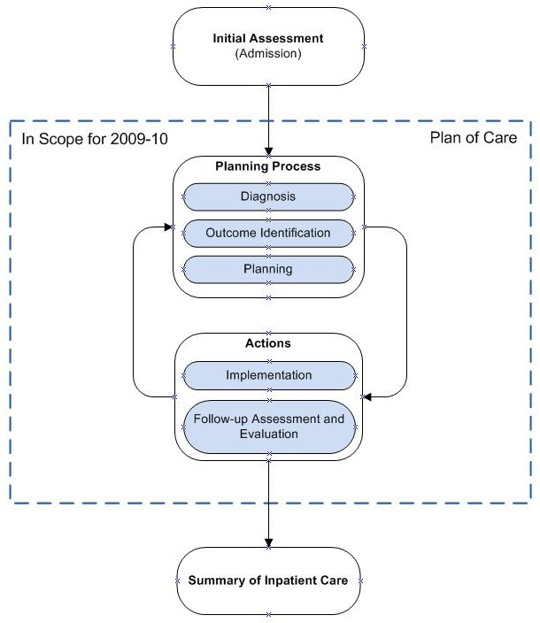
Figure X-1 Nursing Process
This profile defines the implementation of an HL7 CDA document to represent the data elements needed for care planning, along with the IHE profile bindings to support the exchange of the information. The Patient Plan of Care is a content profile that is intended to eventually sit within a larger folder structure that contains documents related to continuity of care for the patient. This profile also defines mechanisms to group them into a single logical folder.
Regardless of where nurses practice, the Patient Plan of Care (PPOC) Profile is able to support coded nursing documentation. This allows healthcare organizations to access quality data on the complexity of patient conditions and the care performed by professional nurses, improve care quality, and facilitate continuity of care.

X.1 Actors and Transactions
There are two actors in this profile, the Content Creator and the Content Consumer. Content is created by a Content Creator and is to be consumed by a Content Consumer. The sharing or transmission of content from one actor to the other is addressed by the appropriate use of IHE profiles described below, and is out of scope of this profile. A Document Source or a Portable Media Creator may embody the Content Creator Actor. A Document Consumer, a Document Recipient or a Portable Media Importer may embody the Content Consumer Actor. The sharing or transmission of content or updates from one actor to the other is addressed by the use of appropriate IHE profiles described by section 3.7 Content Bindings with XDS, XDM and XDR found in the Patient Care Coordination Technical Framework


Figure X.1-2 Patient Plan of Care Actors and Transactions

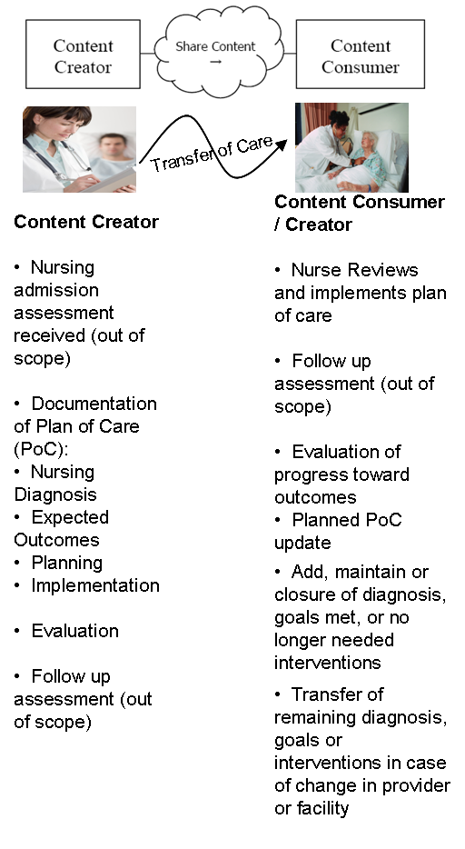

X.2 Patient Plan of Care Options
Actor | Option | Section
Content Consumer | View Option (See Note 1)  Document Import Option (See Note 1)  Section Import Option (See Note 1)  Discrete Data Import Option (See Note 1) | PCC TF-2: 3.0.1  PCC TF-2: 3.0.2  PCC TF-2: 3.0.3  PCC TF-2: 3.0.4
Note 1: The Actor shall support at least one of these options.

X.3 Grouping
This section describes the behaviors expected of the Content Creator and Content Consumer actors of this profile when grouped with actors of other IHE profiles.

X.3.1 Content Bindings with XDS, XDM and XDR
It is expected that the exchanges of this content will occur in an environment where the physician offices and hospitals have a coordinated infrastructure that serves the information sharing needs of this community of care. Several mechanisms are supported by IHE profiles:
- A registry/repository-based infrastructure is defined by the IHE Cross Enterprise Document Sharing (XDS) and other IHE Integration Profiles such as patient identification (PIX & PDQ) and notification of availability of documents (NAV).
- A media-based infrastructure is defined by the IHE Cross Enterprise Document Media Interchange (XDM) profile.
- A reliable messaging-based infrastructure is defined by the IHE Cross Enterprise Document Reliable Interchange (XDR) profile.
- All of these infrastructures support Security and privacy through the use of the Consistent Time (CT) and Audit Trail and Node Authentication (ATNA) profiles.
For more details on these profiles, see the IHE IT Infrastructure Technical Framework. Content profiles may impose additional requirements on the transactions used when grouped with actors from other IHE Profiles.

X.3.2 Cross Enterprise Document Sharing, Media Interchange and Reliable Messages
Actors from the ITI XDS, XDM and XDR profiles most often embody the Content Creator and Content Consumer sharing function of this profile. A Content Creator or Content Consumer may be grouped with appropriate actors from the XDS, XDM or XDR profiles, and the metadata sent in the document sharing or interchange messages has specific relationships to the content of the clinical document described in the content profile.

X.3.3 Audit Trail and Node Authentication (ATNA)
When the Content Creator or Content Consumer actor of this profile is grouped with the Secure Node or Secure Application actor of the ATNA profile, the content creator actor shall generate appropriate audit record events for each of the following trigger events:
Trigger Event | Description
Actor-start-stop | Start up and shut-down of the content creator or content consumer actor.
Patient-Record-Event | Creation, access, modification or deletion of the content described within this profile.
Node-Authentication-Failure | Secure node authentication failure is detected.
The above list is a minimum set that must be demonstrated by all actors of this profile when grouped with the secure node or secure application actor. Additional audit records shall also be generated depending upon the actions available the product implementing the secure node or secure application actor.

X.3.4 Notification of Document Availability (NAV)
A Document Source should provide the capability to issue a Send Notification Transaction per the ITI Notification of Document Availability (NAV) Integration Profile in order to notify one or more Document Consumer(s) of the availability of one or more documents for retrieval. One of the Acknowledgement Request options may be used to request from a Document Consumer that an acknowledgement should be returned when it has received and processed the notification. A Document Consumer should provide the capability to receive a Receive Notification Transaction per the NAV Integration Profile in order to be notified by Document Sources of the availability of one or more documents for retrieval. The Send Acknowledgement option may be used to issue a Send Acknowledgement to a Document Source that the notification was received and processed.

X.3.5 Document Digital Signature (DSG)
When a Content Creator Actor needs to digitally sign a document in a submission set, it may support the Digital Signature (DSG) Content Profile as a Document Source. When a Content Consumer Actor needs to verify a Digital Signature, it may retrieve the digital signature document and may perform the verification against the signed document content.

X.4 Content Modules
Content Modules describe the content of a payload found in an IHE transaction. Content profiles are transaction neutral. They do not have dependencies upon the transaction that they appear in. This integration profile defines one content module, the Patient Plan of Care, defined in section PCC TF-2:6.1.1.Y.
While the Patient Plan of Care focuses on the nursing process. It is intended to be a summary document containing the necessary information for the care planning process.
This content module incorporates other content modules already present in this Technical Framework. The names of these content modules do not always use the terminology found in nursing (e.g., Review of Systems). However, the data elements found in these sections are identical in content regardless of the scope of practice for the author providing that information, be they nurse, physician or other health care professional.
The purpose of section is to identify the type of information found in it. The author that generated this information is separately identified within the content module. Those two pieces together provide sufficent information to interpret the content.

X.5 Patient Plan of Care Process Flow
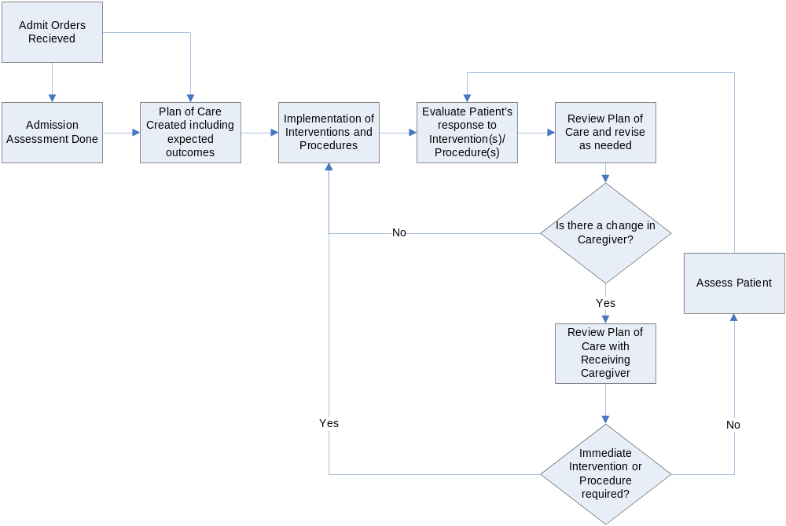
This process flow diagram shows the movement of the Patient Plan of Care over the course of care for a patient as an inpatient on a Nursing Unit. This diagram specifically excludes other infrastructure interactions for simplicity and readability. These infrastructure interactions may be found elsewhere in this and other IHE frameworks.
The data from a Patient Plan of Care are exchanged electronically between and among health technology information systems for each of the steps of the Nursing Process. The Plan of Care may also be exchanged with consultants and other interested providers who may then update the Patient Plan of Care, and return the updated record to the sender, primary care provider, patient, and/or other interested providers.

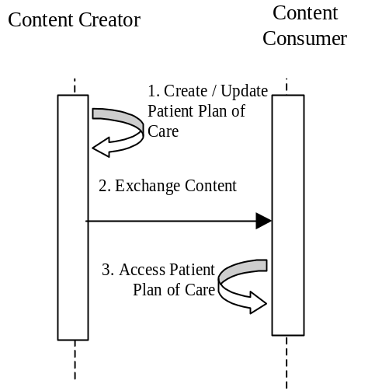
Figure X.3-1. Basic Process Flow in the Patient Plan of Care Profile
The following steps show the use of the Patient Plan of Care Profile during the nursing process.
- A patient admitted as an inpatient to a hospital for a medical diagnosis or a surgical procedure requires nursing care. A Nurse reviews the Provider medical orders and develops an individualized Plan of Care with the patient based on the Nursing Process. This model includes nursing orders within the electronic health record (EHR) system. The Nurse documents a specific Plan of Care using coded nursing terminology.
- The plan of care is stored within an HIT system.
- The Patient Plan of Care is active as long as the patient remains an inpatient and until the patient is discharged or transferred. During the inpatient stay, the Nurse reviews the patient’s Plan of Care shift by shift to ensure that patient progress and quality care are maintained and nursing interventions are evaluated. When there is a change in the patient’s medical condition the Patient Plan of Care is revised as needed back at step 1.
The following describes these same steps used in the context of a transfer of care.
- When a patient is transferred to another facility the Patient Plan of Care is revised for the continuity of care.
- The updated patient plan of care is exchanged with the destination facility.
- The plan of care is reviewed at the destination facility and may be updated again at the first step.

X.6 Patient Plan of Care Security Considerations
<Description of the Profile specific security considerations. This should include the outcomes of a risk assessment. This likely will include profile groupings, and residual risks that need to be assigned to the product design, system administration, or policy.>

Volume 2 – Transactions and Content
Add section 6.1.1.Y to the end of section 6.1.1

6.1.1 CDA Document Content Modules

6.1.1.Y Care Plan Specification 1.3.6.1.4.1.19376.1.5.3.1.1.20.1.1
The nursing evaluation and management note contains the information relevant to the six components of the nursing process described by the American Nursing Association Standards of Nursing Practice (ANA 2004). These include:
- Assessment
The assessment includes nursing assessments, review of systems and/or physical examination details and vital signs as necessary, as well as any necessary assessments of functional status or risks to the patient. Additional sections may be added to include relevant family / social history, or other key knowledge necessary to the implementation of the nursing plan.
- Diagnosis
The problem list section includes any diagnoses based on assessments and information received from other providers.
- Expected Outcomes
Identification of the expected outcomes for the patient (the goals).
- Planning
Planning describes the treatments and interventions to be implemented to reach the expected outcomes under the plan.
- Implementation
The procedures and interventions section is used to report the actions performed and care provided to the patient.
- Evaluation
The progress notes section is where the evaluation of the effectiveness of the plan towards the goals is documented, and may include assessments of the patient response to the treatment plan.
In addition to these sections, the care plan also includes other information relevant to the planning process, including the following:
- Orders
The care plan must include a section referencing provider orders and actions that are to be implemented, including any orders for treatment (e.g., medications, therapy, et cetera), monitoring (testing, monitoring, et cetera) or education.
- Allergies
The care plan must document the presense or absense of patient allergies.
- Past Medical History
The care plan shall include past medical history relevant to care planning
- Surgical History
The care plan shall include any relevant prior surgical history.
- Advance Directives
The care plan shall include information about any relevant advance directives or note their absense.
- Immunizations
The care plan should include information about the patient’s immunization status (e.g., recent flu shot).
- Family and Social History
The care plan may include information about relevent family and social history pertinent to care planning.
The document content module specifies which IHE templates to use for each of the above components. However, the sections described above are not necessarily an exhaustive list of all necessary sections. Additional information may be required based on the context of the care being provided. For example, when treating a patient in a labor and delivery setting, information such as the patient’s pregnancy history would be needed. The IHE PCC Technical framework contains a library of section templates that may be used within this document content module.

6.1.1.Y.1 LOINC Code
The LOINC code for this document is 34746-8 Nursing Evaluation and Management Note

6.1.1.Y.2 Standards
CDAR2 | HL7 CDA Release 2.0
CCD | ASTM/HL7 Continuity of Care Document
ANA 2004 | ANA Nursing Scope and Standard of Practice

6.1.1.Y.3 Data Element Index
Data Element | LOINC | ANA 2004
Assessment | X-ASSESS ASSESSMENTS | Assessment
Physical Examination | 29545-1 PHYSICAL EXAMINATION | Assessment
Review of Systems | 10187-3 REVIEW OF SYSTEMS | Assessment
Functional Status Assessment | 47420-5 FUNCTIONAL STATUS ASSESSMENT | Assessment
Family History | 10157-6 HISTORY OF FAMILY MEMBER DISEASES | Assessment
Social History | 29762-2 SOCIAL HISTORY | Assessment
Active Problems | 11450-4 PROBLEM LIST | Diagnosis
Allergies | 48765-2 Allergies, adverse reactions, alerts | Diagnosis
Goals | X-OUTCOME Outcome Identification | Outcome Identification
Care Plan | 18776-5 Plan of Treatment | Planning
Provider Orders | 46209-3 PROVIDER ORDERS | Planning
Advance Directives | 42348-3 ADVANCE DIRECTIVES | Planning
Procedures and Interventions | 29544-3 PROCEDURES | Implementation
Medications Administered | 18610-6 MEDICATION ADMINISTERED | Implementation
Fluids Administered | 8975-5 INTRAVASCULAR FLUID INTAKE | Implementation
Progress | 27574-3 Progress Note and Attainment of Goals | Evaluation
History of Past Illness | 11348-0 HISTORY OF PAST ILLNESS
Surgical History | 47519-4 HISTORY OF PROCEDURES

6.1.1.Y.4 Specification
Data Element Name | Opt | Template ID
Assessments  This section shall include all assessments performed. | R | 1.3.6.1.4.1.19376.1.5.3.1.1.13.2.4
Physical Examination  The physical examination section shall be present when a physical examination is performed during the assessment of the patient. | C | 1.3.6.1.4.1.19376.1.5.3.1.1.9.15
Review of Systems  The review of systems section shall be present when a review of systems is performed during the assessment of the patient. | C | 1.3.6.1.4.1.19376.1.5.3.1.3.18
Functional Status Assessment  This section shall be present when any assessments of functional status were performed on on the patient. | C | 1.3.6.1.4.1.19376.1.5.3.1.1.12.2.1
Family History | O | 1.3.6.1.4.1.19376.1.5.3.1.3.14
Social History | O | 1.3.6.1.4.1.19376.1.5.3.1.3.16
Active Problems  The problem list section includes any nursing and physician diagnoses that are relevant to or being treated by the care plan. | R | 1.3.6.1.4.1.19376.1.5.3.1.3.6
Allergies and Other Adverse Reactions Section  This section shall be present and record the presense or absense of any allergies. | R | 1.3.6.1.4.1.19376.1.5.3.1.3.13
Care Plan  The care plan section contain a description of the care requirements. | R | 1.3.6.1.4.1.19376.1.5.3.1.3.31
Provider Orders  References any orders that are to be implemented, including those for treatment (e.g., medications, therapy or therapeutic encounters, et cetera), monitoring (testing, monitoring, et cetera), or education. | R | 1.3.6.1.4.1.19376.1.5.3.1.1.20.2.1
Advance Directives Section  This section shall be present and record the presence or absense of any advance directives. | R | 1.3.6.1.4.1.19376.1.5.3.1.3.34
Procedures and Interventions  This section shall be present when procedures and interventions have been performed. | C | 1.3.6.1.4.1.19376.1.5.3.1.1.13.2.11
Medications Administered  This section shall be present when medications have been administered. | C | 1.3.6.1.4.1.19376.1.5.3.1.3.21
Fluids Administered  This section shall be present when fluids have been administered. | C | 1.3.6.1.4.1.19376.1.5.3.1.1.13.2.6
History of Past Illness Section  This section shall be present when there is relevant history of past illness. | C | 1.3.6.1.4.1.19376.1.5.3.1.3.8
Coded List of Surgeries Section  This section shall be present when there is relevant surgical history. | C | 1.3.6.1.4.1.19376.1.5.3.1.3.12
Immunizations Section  This section shall be present to record relevant immunization status. | C | 1.3.6.1.4.1.19376.1.5.3.1.3.23

6.1.1.Y.5 Conformance
CDA Release 2.0 documents that conform to the requirements of this content module shall indicate their conformance by the inclusion of the appropriate <templateId> elements in the header of the document. This is shown in the sample document below.
Sample Care Plan Document
<ClinicalDocument xmlns='urn:hl7-org:v3'>
<typeId extension="POCD_HD000040" root="2.16.840.1.113883.1.3"/>
<templateId root='1.3.6.1.4.1.19376.1.5.3.1.1.20.1.1'/>
<id root=' ' extension=' '/>
<code code='34746-8' displayName='Nursing Evaluation and Management Note'
codeSystem='2.16.840.1.113883.6.1' codeSystemName='LOINC'/>
<title>Care Plan</title>
<effectiveTime value='20090506012005'/>
<confidentialityCode code='N' displayName='Normal'
codeSystem='2.16.840.1.113883.5.25' codeSystemName='Confidentiality' />
<languageCode code='en-US'/>
:
<component><structuredBody>
<component>
<section>
<templateId root='1.3.6.1.4.1.19376.1.5.3.1.1.13.2.4'/>
<!-- Required Assessments Section content -->
</section>
</component>
<component>
<section>
<templateId root='1.3.6.1.4.1.19376.1.5.3.1.1.9.15'/>
<!-- Conditional Physical Examination Section content -->
</section>
</component>
<component>
<section>
<templateId root='1.3.6.1.4.1.19376.1.5.3.1.3.18'/>
<!-- Conditional Review of Systems Section content -->
</section>
</component>
<component>
<section>
<templateId root='1.3.6.1.4.1.19376.1.5.3.1.1.12.2.1'/>
<!-- Conditional Functional Status Assessment Section content -->
</section>
</component>
<component>
<section>
<templateId root='1.3.6.1.4.1.19376.1.5.3.1.3.14'/>
<!-- Optional Family History Section content -->
</section>
</component>
<component>
<section>
<templateId root='1.3.6.1.4.1.19376.1.5.3.1.3.16'/>
<!-- Optional Social History Section content -->
</section>
</component>
<component>
<section>
<templateId root='1.3.6.1.4.1.19376.1.5.3.1.3.6'/>
<!-- Required Active Problems Section content -->
</section>
</component>
<component>
<section>
<templateId root='1.3.6.1.4.1.19376.1.5.3.1.3.13'/>
<!-- Required Allergies and Other Adverse Reactions Section Section content -->
</section>
</component>
<component>
<section>
<templateId root='1.3.6.1.4.1.19376.1.5.3.1.3.31'/>
<!-- Required Care Plan Section content -->
</section>
</component>
<component>
<section>
<templateId root='1.3.6.1.4.1.19376.1.5.3.1.1.20.2.1'/>
<!-- Required Provider Orders Section content -->
</section>
</component>
<component>
<section>
<templateId root='1.3.6.1.4.1.19376.1.5.3.1.3.34'/>
<!-- Required Advance Directives Section content -->
</section>
</component>
<component>
<section>
<templateId root='1.3.6.1.4.1.19376.1.5.3.1.1.13.2.11'/>
<!-- Conditional Procedures and Interventions Section content -->
</section>
</component>
<component>
<section>
<templateId root='1.3.6.1.4.1.19376.1.5.3.1.3.21'/>
<!-- Conditional Medications Administered Section content -->
</section>
</component>
<component>
<section>
<templateId root='1.3.6.1.4.1.19376.1.5.3.1.1.13.2.6'/>
<!-- Conditional Fluids Administered Section content -->
</section>
</component>
<component>
<section>
<templateId root='1.3.6.1.4.1.19376.1.5.3.1.3.8'/>
<!-- Conditional History of Past Illness Section Section content -->
</section>
</component>
<component>
<section>
<templateId root='1.3.6.1.4.1.19376.1.5.3.1.3.12'/>
<!-- Conditional Coded List of Surgeries Section Section content -->
</section>
</component>
<component>
<section>
<templateId root='1.3.6.1.4.1.19376.1.5.3.1.3.23'/>
<!-- Conditional Immunizations Section Section content -->
</section>
</component>

</structuredBody></component>
</ClinicalDocument>

6.1.1.Y.6 Schematron
<pattern name='Template_1.3.6.1.4.1.19376.1.5.3.1.1.20.1.1'>
<rule context='*[cda:templateId/@root="1.3.6.1.4.1.19376.1.5.3.1.1.20.1.1"]'>
<!-- Verify that the template id is used on the appropriate type of object -->
<assert test='../cda:ClinicalDocument'>
Error: The Care Plan can only be used on Clinical Documents.
</assert>
<!-- Verify the document type code -->
<assert test='cda:code[@code = "34746-8"]'>
Error: The document type code of a Care Plan must be 34746-8
</assert>
<assert test='cda:code[@codeSystem = "2.16.840.1.113883.6.1"]'>
Error: The document type code must come from the LOINC code
system (2.16.840.1.113883.6.1).
</assert>
<assert test='.//cda:templateId[@root = "1.3.6.1.4.1.19376.1.5.3.1.1.13.2.4"]'>
<!-- Verify that all required data elements are present -->
Error: The Care Plan Document must contain a(n) Assessments Section.
See http://wiki.ihe.net/index.php?title=1.3.6.1.4.1.19376.1.5.3.1.1.20.1.1
</assert>
<assert test='.//cda:templateId[@root = "1.3.6.1.4.1.19376.1.5.3.1.1.9.15"]'>
<!-- Manually verify condtional elements -->
Manual: This Care Plan Document does not contain a(n) Physical Examination Section.
See http://wiki.ihe.net/index.php?title=1.3.6.1.4.1.19376.1.5.3.1.1.20.1.1
</assert>
<assert test='.//cda:templateId[@root = "1.3.6.1.4.1.19376.1.5.3.1.3.18"]'>
<!-- Manually verify condtional elements -->
Manual: This Care Plan Document does not contain a(n) Review of Systems Section.
See http://wiki.ihe.net/index.php?title=1.3.6.1.4.1.19376.1.5.3.1.1.20.1.1
</assert>
<assert test='.//cda:templateId[@root = "1.3.6.1.4.1.19376.1.5.3.1.1.12.2.1"]'>
<!-- Manually verify condtional elements -->
Manual: This Care Plan Document does not contain a(n) Functional Status Assessment Section.
See http://wiki.ihe.net/index.php?title=1.3.6.1.4.1.19376.1.5.3.1.1.20.1.1
</assert>
<assert test='.//cda:templateId[@root = "1.3.6.1.4.1.19376.1.5.3.1.3.14"]'>
<!-- Note any missing optional elements -->
Note: This Care Plan Document does not contain a(n) Family History Section.
See http://wiki.ihe.net/index.php?title=1.3.6.1.4.1.19376.1.5.3.1.1.20.1.1
</assert>
<assert test='.//cda:templateId[@root = "1.3.6.1.4.1.19376.1.5.3.1.3.16"]'>
<!-- Note any missing optional elements -->
Note: This Care Plan Document does not contain a(n) Social History Section.
See http://wiki.ihe.net/index.php?title=1.3.6.1.4.1.19376.1.5.3.1.1.20.1.1
</assert>
<assert test='.//cda:templateId[@root = "1.3.6.1.4.1.19376.1.5.3.1.3.6"]'>
<!-- Verify that all required data elements are present -->
Error: The Care Plan Document must contain a(n) Active Problems Section.
See http://wiki.ihe.net/index.php?title=1.3.6.1.4.1.19376.1.5.3.1.1.20.1.1
</assert>
<assert test='.//cda:templateId[@root = "1.3.6.1.4.1.19376.1.5.3.1.3.13"]'>
<!-- Verify that all required data elements are present -->
Error: The Care Plan Document must contain a(n) Allergies and Other Adverse Reactions Section Section.
See http://wiki.ihe.net/index.php?title=1.3.6.1.4.1.19376.1.5.3.1.1.20.1.1
</assert>
<assert test='.//cda:templateId[@root = "1.3.6.1.4.1.19376.1.5.3.1.3.31"]'>
<!-- Verify that all required data elements are present -->
Error: The Care Plan Document must contain a(n) Care Plan Section.
See http://wiki.ihe.net/index.php?title=1.3.6.1.4.1.19376.1.5.3.1.1.20.1.1
</assert>
<assert test='.//cda:templateId[@root = "1.3.6.1.4.1.19376.1.5.3.1.1.20.2.1"]'>
<!-- Verify that all required data elements are present -->
Error: The Care Plan Document must contain a(n) Provider Orders Section.
See http://wiki.ihe.net/index.php?title=1.3.6.1.4.1.19376.1.5.3.1.1.20.1.1
</assert>
<assert test='.//cda:templateId[@root = "1.3.6.1.4.1.19376.1.5.3.1.3.34"]'>
<!-- Verify that all required data elements are present -->
Error: The Care Plan Document must contain a(n) Advance Directives Section.
See http://wiki.ihe.net/index.php?title=1.3.6.1.4.1.19376.1.5.3.1.1.20.1.1
</assert>
<assert test='.//cda:templateId[@root = "1.3.6.1.4.1.19376.1.5.3.1.1.13.2.11"]'>
<!-- Manually verify condtional elements -->
Manual: This Care Plan Document does not contain a(n) Procedures and Interventions Section.
See http://wiki.ihe.net/index.php?title=1.3.6.1.4.1.19376.1.5.3.1.1.20.1.1
</assert>
<assert test='.//cda:templateId[@root = "1.3.6.1.4.1.19376.1.5.3.1.3.21"]'>
<!-- Manually verify condtional elements -->
Manual: This Care Plan Document does not contain a(n) Medications Administered Section.
See http://wiki.ihe.net/index.php?title=1.3.6.1.4.1.19376.1.5.3.1.1.20.1.1
</assert>
<assert test='.//cda:templateId[@root = "1.3.6.1.4.1.19376.1.5.3.1.1.13.2.6"]'>
<!-- Manually verify condtional elements -->
Manual: This Care Plan Document does not contain a(n) Fluids Administered Section.
See http://wiki.ihe.net/index.php?title=1.3.6.1.4.1.19376.1.5.3.1.1.20.1.1
</assert>
<assert test='.//cda:templateId[@root = "1.3.6.1.4.1.19376.1.5.3.1.3.8"]'>
<!-- Manually verify condtional elements -->
Manual: This Care Plan Document does not contain a(n) History of Past Illness Section Section.
See http://wiki.ihe.net/index.php?title=1.3.6.1.4.1.19376.1.5.3.1.1.20.1.1
</assert>
<assert test='.//cda:templateId[@root = "1.3.6.1.4.1.19376.1.5.3.1.3.12"]'>
<!-- Manually verify condtional elements -->
Manual: This Care Plan Document does not contain a(n) Coded List of Surgeries Section Section.
See http://wiki.ihe.net/index.php?title=1.3.6.1.4.1.19376.1.5.3.1.1.20.1.1
</assert>
<assert test='.//cda:templateId[@root = "1.3.6.1.4.1.19376.1.5.3.1.3.23"]'>
<!-- Manually verify condtional elements -->
Manual: This Care Plan Document does not contain a(n) Immunizations Section Section.
See http://wiki.ihe.net/index.php?title=1.3.6.1.4.1.19376.1.5.3.1.1.20.1.1
</assert>
</rule>
</pattern>

6.1.3.6 Plans of Care
Add the following section to the end of section 6.1.3.6.

6.1.3.6.X Provider Orders Section
Template ID | 1.3.6.1.4.1.19376.1.5.3.1.1.20.2.1
General Description | The provider orders shall contain a list of all pertinent orders from healthcare providers.
LOINC Code | Opt | Description
46209-3 | R | PROVIDER ORDERS
Entries | Opt | Description
1.3.6.1.4.1.19376.1.5.3.1.4.7 | C | Medications  Medications entries shall appear for all ordered medications when present. These entries shall be in intent mood.
1.3.6.1.4.1.19376.1.5.3.1.4.19 | C | Procedure  Procedure entries shall appear for all ordered procedures when present. These entries shall be in intent mood.
1.3.6.1.4.1.19376.1.5.3.1.4.14 | O | Encounter  Encounter entries should appear for all ordered encounters. These entries shall be in promise or appointment request mood.
1.3.6.1.4.1.19376.1.5.3.1.1.20.3.1 | O | Observation Requests  Observation request entries should appear for all ordered observations. These entries shall appear in intent mood.

Sample Provider Orders Section
<component>
<section>
<templateId root='1.3.6.1.4.1.19376.1.5.3.1.1.20.2.1'/>
<id root=' ' extension=' '/>
<code code='46209-3' displayName='PROVIDER ORDERS'
codeSystem='2.16.840.1.113883.6.1' codeSystemName='LOINC'/>
<text>
Text as described above
</text>
<entry>
:
<!-- Required if known Medications element -->
<templateId root='1.3.6.1.4.1.19376.1.5.3.1.4.7'/>
:
</entry>
<entry>
:
<!-- Required if known Procedure element -->
<templateId root='1.3.6.1.4.1.19376.1.5.3.1.4.19'/>
:
</entry>
<entry>
:
<!-- Optional Encounter element -->
<templateId root='1.3.6.1.4.1.19376.1.5.3.1.4.14'/>
:
</entry>
<entry>
:
<!-- Optional Observation Requests element -->
<templateId root='1.3.6.1.4.1.19376.1.5.3.1.1.20.3.1'/>
:
</entry>

</section>
</component>

6.1.3.6.X.1 Schematron
<pattern name='Template_1.3.6.1.4.1.19376.1.5.3.1.1.20.2.1'>
<rule context='*[cda:templateId/@root="1.3.6.1.4.1.19376.1.5.3.1.1.20.2.1"]'>
<!-- Verify that the template id is used on the appropriate type of object -->
<assert test='../cda:section'>
Error: The Provider Orders can only be used on sections.
</assert>
<!-- Verify the section type code -->
<assert test='cda:code[@code = "46209-3"]'>
Error: The section type code of a Provider Orders must be 46209-3
</assert>
<assert test='cda:code[@codeSystem = "2.16.840.1.113883.6.1"]'>
Error: The section type code must come from the LOINC code
system (2.16.840.1.113883.6.1).
</assert>
<assert test='.//cda:templateId[@root = "1.3.6.1.4.1.19376.1.5.3.1.4.7"]'>
<!-- Alert on any missing required if known elements -->
Warning: The Provider Orders Section should contain a(n) Medications Entry.
See http://wiki.ihe.net/index.php?title=1.3.6.1.4.1.19376.1.5.3.1.1.20.2.1
</assert>
<assert test='.//cda:templateId[@root = "1.3.6.1.4.1.19376.1.5.3.1.4.19"]'>
<!-- Alert on any missing required if known elements -->
Warning: The Provider Orders Section should contain a(n) Procedure Entry.
See http://wiki.ihe.net/index.php?title=1.3.6.1.4.1.19376.1.5.3.1.1.20.2.1
</assert>
<assert test='.//cda:templateId[@root = "1.3.6.1.4.1.19376.1.5.3.1.4.14"]'>
<!-- Note any missing optional elements -->
Note: This Provider Orders Section does not contain a(n) Encounter Entry.
See http://wiki.ihe.net/index.php?title=1.3.6.1.4.1.19376.1.5.3.1.1.20.2.1
</assert>
<assert test='.//cda:templateId[@root = "1.3.6.1.4.1.19376.1.5.3.1.1.20.3.1"]'>
<!-- Note any missing optional elements -->
Note: This Provider Orders Section does not contain a(n) Observation Requests Entry.
See http://wiki.ihe.net/index.php?title=1.3.6.1.4.1.19376.1.5.3.1.1.20.2.1
</assert>
</rule>
</pattern>

Add the following Appendix to Volume 2

Clinical documents are not normally modified after being finalized. However, prior to that event one or more parties may author the content in stages. Each subsequent stage should be treated as a modification of the previous stage.
This step does not always involve and exchange between different HIT systems.

